**Weather App**

A simple weather forecast application based on the Open Weather APIs, The features include the basics, including forecasts, current temperature, hourly forecasts, and more.

**Highlights**

* Use [OpenWeatherMap](https://openweathermap.org/) API
* Bootstrap
* CSS
* Html
* jQuery

1.Home Page

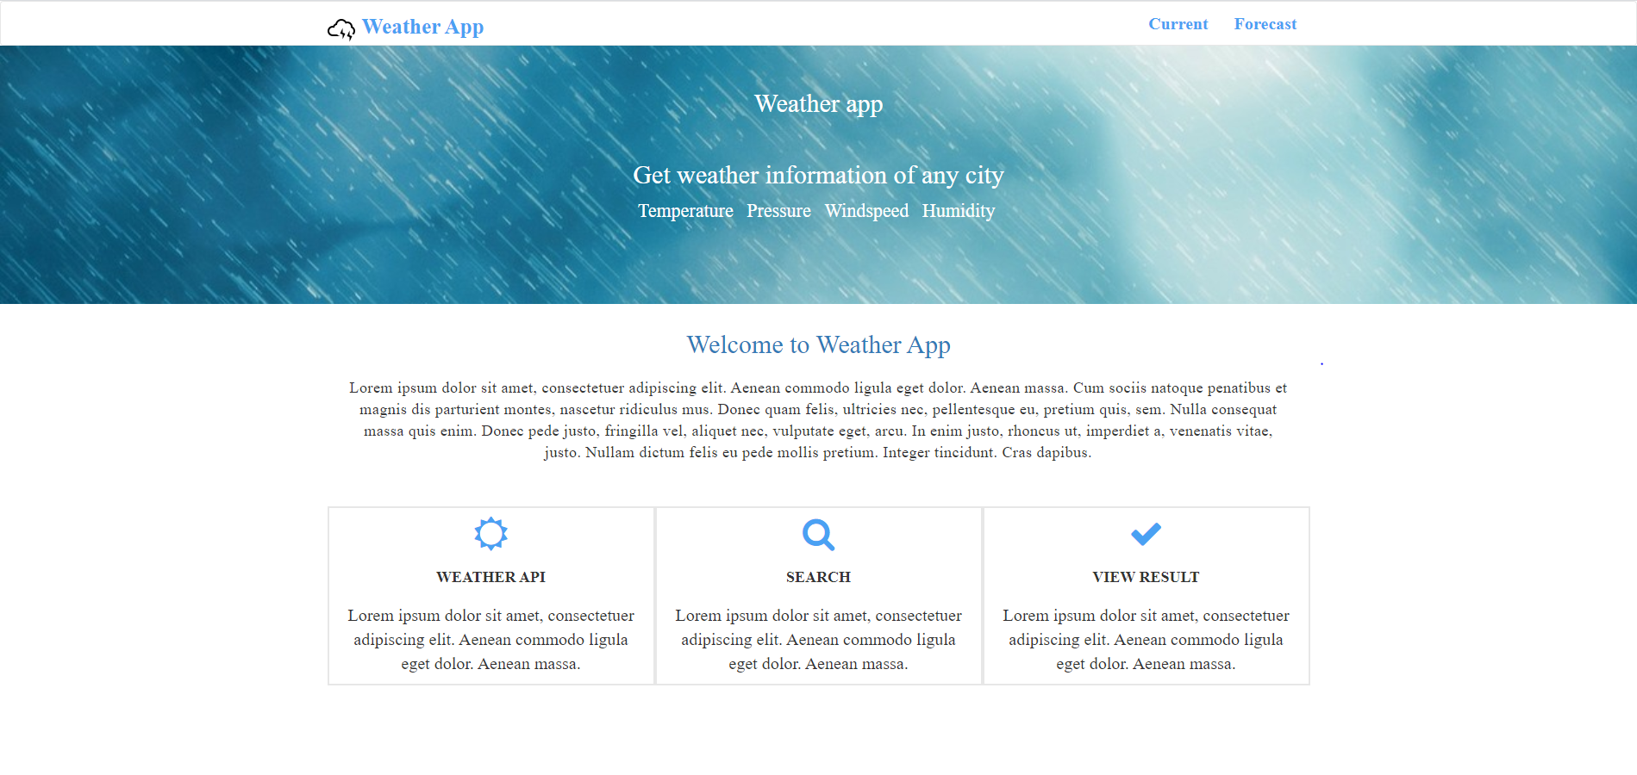

2.Click the Current button on homepage

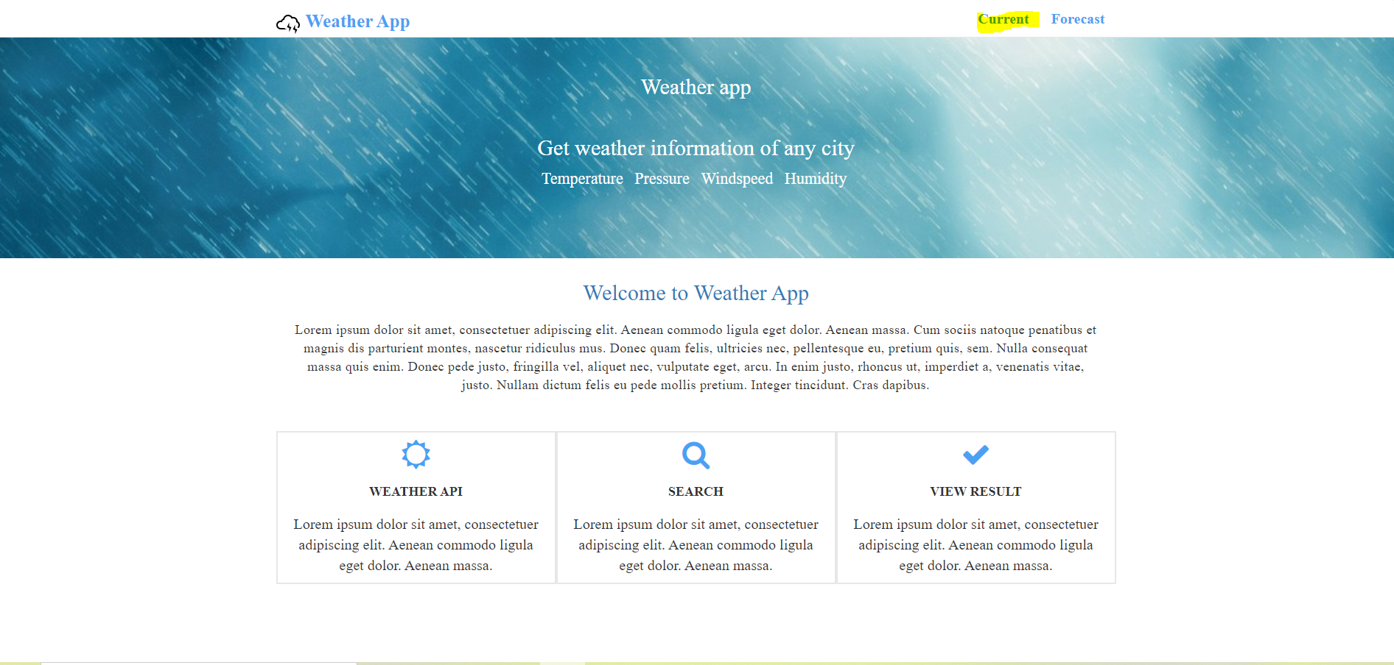

3.Enter the city Name

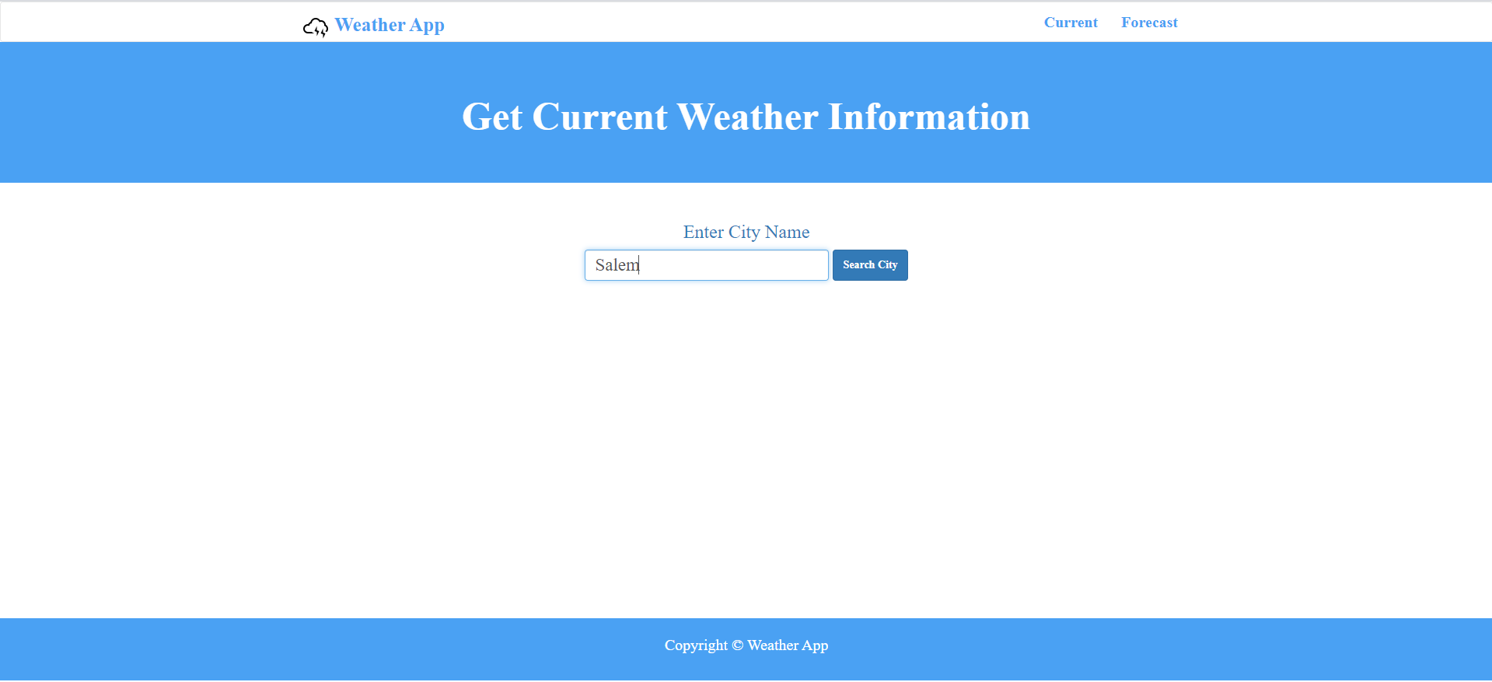

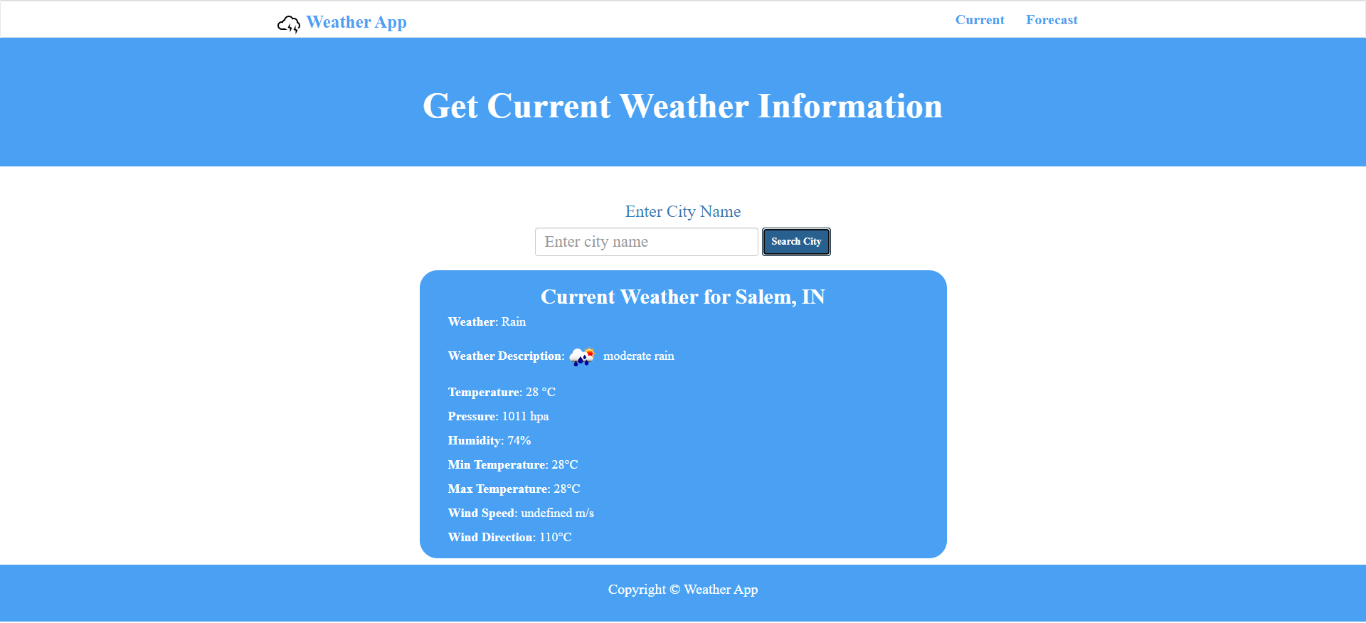

Result of the current city weather result will be shown

Forecast For Upcoming Days

Click on the forecast button on navbar

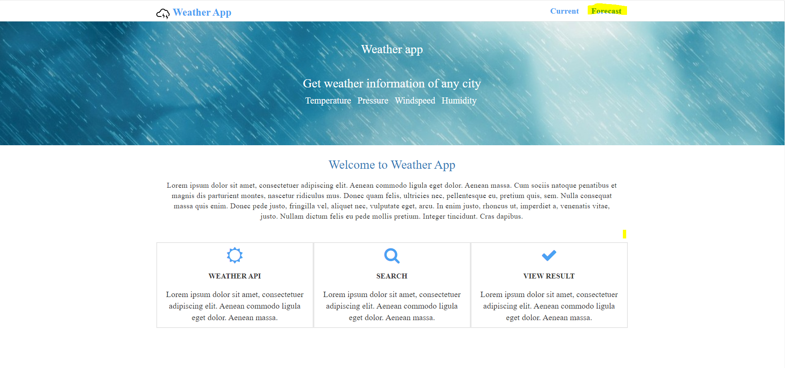

Select the city and Number of days

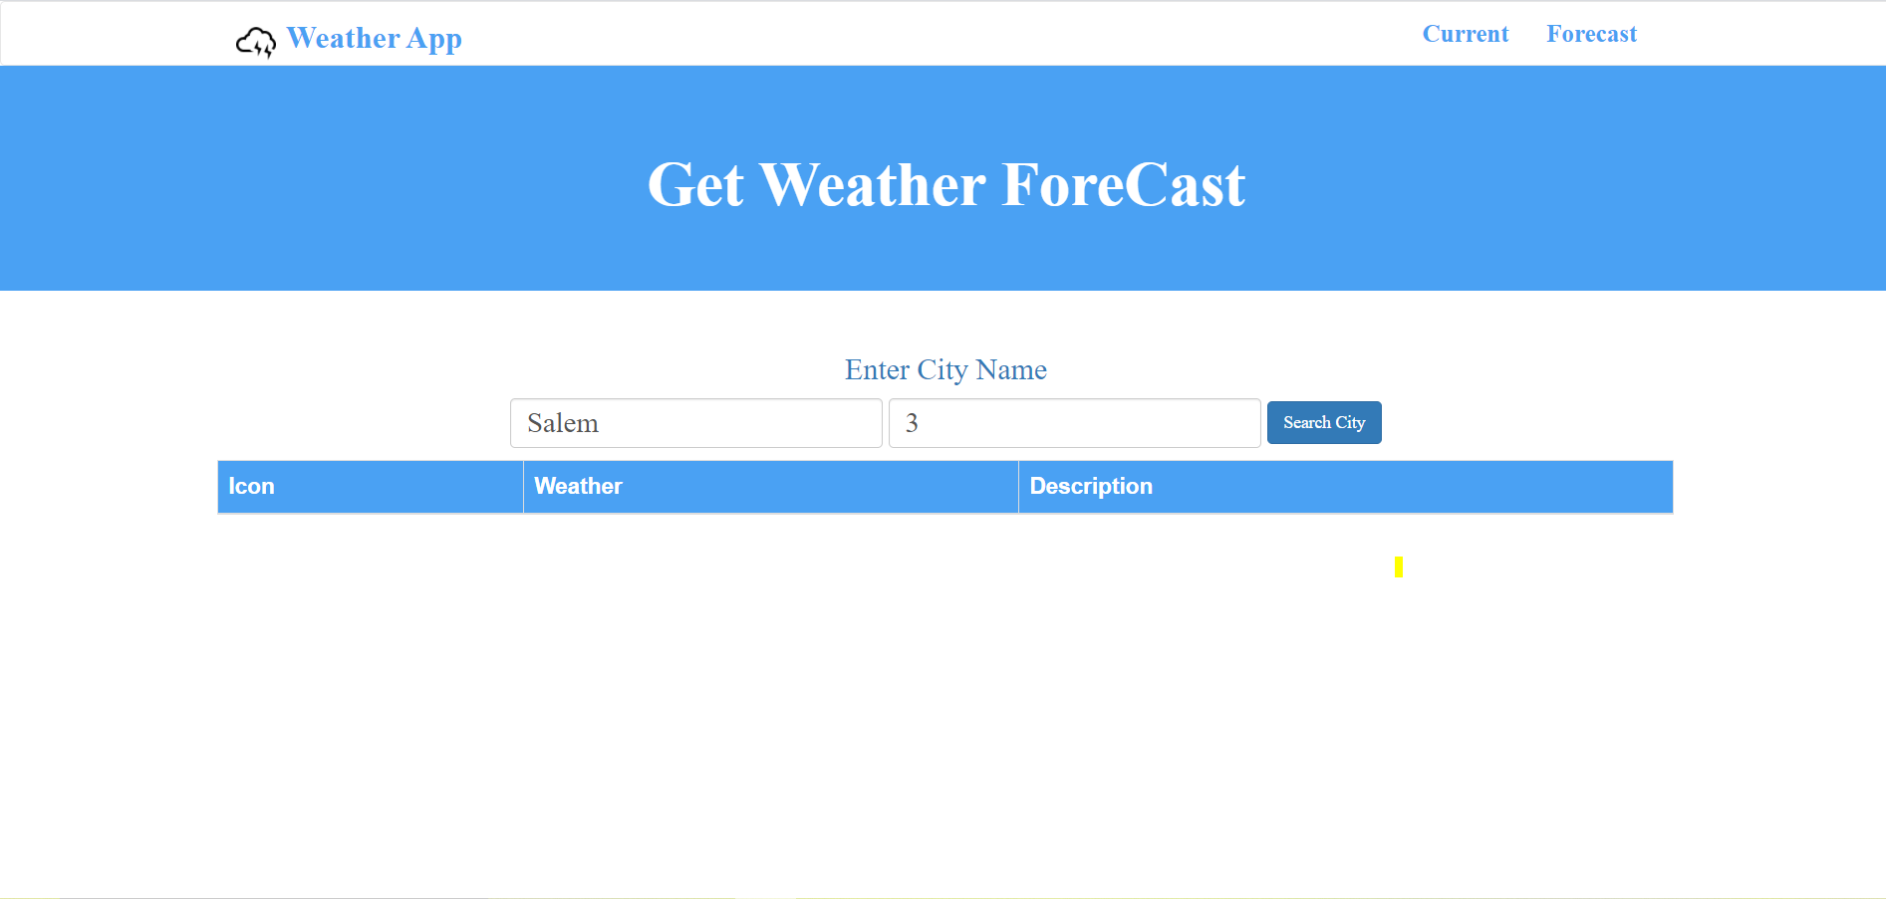

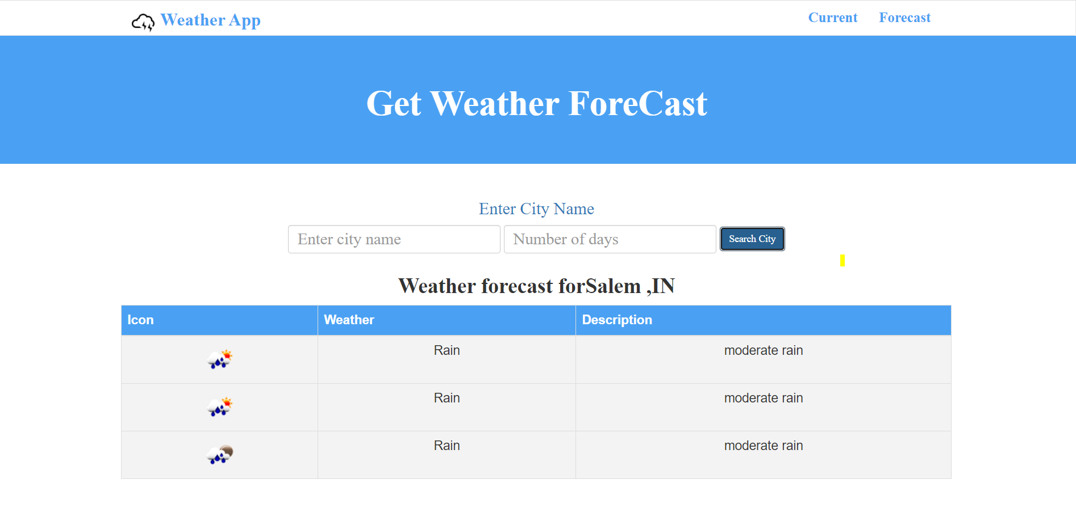

Result of the current city weather result for upcoming days will be shown